## A Project Report

**ON**

**‘Weather Station using IoT’**

Submitted in the partial fulfillment of the requirements for the PG Diploma

In

**Embedded Systems and Design (PG-DESD)**

By

## Jyoti Bhosale (E1 83865)

## Gayatri Pannam (E1 84190)

**Poonam Shinde (E1 83678)**



Sunbeam Institute of Information Technology, Pune and Karad

Year: 2024

**Sunbeam Institute of Information Technology, Pune and Karad.**

CERTIFICATE

Certified that the Project Progress report entitled, **‘Weather Station using IoT’** is a bonafied work done by

## Jyoti Bhosale (E1 83865) Gayatri Pannam (E1 84190)

**Ponnam Shinde (E1 83678)**

in partial fulfillment of the requirements for the award of **PG Diploma in Embedded Systems and Design (PG-DESD)**

Date: 08/0/2021

E-Mail:

Student:

jsbhosale9696[@gmail.com](mailto:jadhavrushi3499@gmail.com) [gayatripannam124@gmail.com](mailto:pawarmayani@gmail.com) [poonamshinde1912@gmail.com](mailto:hans954515@gmail.com)

# ACKNOWLEDEMENT

I dream it a great pleasure and privilege to have an opportunity to take up the project work under the guidance **Prof. Devendra Dhande** and **Prof. Ganesh Gundare**, of “**Sunbeam Institute of Information Technology, Pune and Karad.**” and empress gratitude for rendered excellent guidance and valuable suggestions.

Finally, I thank all friends for their valuable help and all those who directly or indirectly helped me for completion of this project report.

**Jyoti Bhosale (E1 83865) Gayatri Pannam (E1 84190)**

**Poonam Shinde (E1 83678)**

# Index

|  |  |  |
| --- | --- | --- |
| **Contents** | | **Page** |
| ABSTRACT | | 01 |
|  | |  |
| 1 | Introduction | 02 |
|  | |  |
| 1. Required Components and Their Specifications   2.1 Node MCUEsp-8266  2.2Rain Sensor module  2.3 LDR Module  2.4 DHT11  2.3 Miscellaneous Components  2.3.1 USB Micro B  2.3.2 Breadboard  2.3.3 Connecting Wires | | 03-09 |
|  | |  |
| 3 | Software requirement   * 1. Arduino IDE   2. Visual Studio Code | 10 |
|  | |  |
| 4 | Flowchart of Project | 11 |
|  | |  |
| 1. Block diagram of project    1. Explanation of Block diagram    2. Project Design & Explanation   5.2.1 Hardware Part  5.2.2 Server Part | | 12-17 |
|  | |  |
| 6 | Result   * 1. Database   2. Thingspeak Channel Graphical Representation | 18-20 |
|  | |  |
| 1. Advantage of weather station | | 21 |
|  | |  |
| 8 | Approximate Costing | 21 |
|  | |  |
| 9 | Future scope | 22 |
|  | |  |
| 10 Conclusion | | 23 |
|  | |  |
| 11 References | | 24 |

**ABSTRACT**

The Weather Monitoring and Reporting System that is based on the Internet of Things (IoT) is used to provide real-time updates on weather conditions such as temperature, humidity, moisture, and rain levels. For instance, if scientists or nature analysts need to monitor changes in a specific environment like a volcano or a rainforest, they may face limitations with an SMSbased weather monitoring system that only sends messages to a few recipients, and the time required for sending messages increases with the number of mobile numbers. In such cases, individuals would need to visit specific sites to access information on the weather conditions, which is visible to everyone. Due to drastic changes in climate, weather forecasts are becoming increasingly unpredictable. As a result, Weather Reporting Systems are being primarily used for real-time monitoring of continuously changing weather and climatic conditions in controlled areas like homes, industries, and agriculture. The IoT platform, ThingSpeak, is utilized for displaying weather parameters and information globally. This information is also displayed on an OLED using two-way microcontroller communication via Wi-Fi hotspots. Reports on weather conditions for particular places that are based on satellite systems may not provide exact weather conditions, which can be problematic when accurate weather reports are needed in real-time. In the Weather Reporting System, all weather parameters sensors are controlled by an ESP32 microcontroller acting as the server that sends all the data collected by sensors to the ThingSpeak database, which is visible worldwide and displayed on the OLED using a Wemos DI mini as the client microcontroller. The collected data is then compared to weather forecast data and statistics generated by forecast stations. To simplify data analysis, all collected data is saved in Google Sheets format using the IFTT tool. This system monitors changes in weather conditions occurring in the environment and provides users with the quickest way to access information

##### Index Terms—

Arduino ESP8266, MySQL, Python Server, Channel,IDAPI Key, ThingspeakIoTcloud.

# INTRODUCTION

Environment essentially affects individuals' life. Air quality and the quality of the environment have been significantly impacted by the extraordinary rise in industry and automobile traffic. The current situation is provided by the satellite weather reporting system, but it does not accurately reflect the state of each location. Although precise meteorological data for the specific location of the building is required to enhance the calibration of energy simulation programs, the building industry has a high potential for energy savings. By constructing a controlled local weather reporting system with Wemo's D1 small microcontroller and the ESP32, the error in the weather forecasting system at the specific location can be minimized. The science and art of using technology to increase agricultural yield is known as precision agriculture. Even though water is a finite resource, 50% of the water used in agriculture is wasted due to improper irrigation scheduling. In this scenario, real-time monitoring of the amount of water used in fields can help prevent water waste. The use of technology in agriculture is essential for increasing output and reducing human labor requirements. A lot of attention has been paid to some recent research that aims to improve environmental and climate change monitoring. Individuals want to understand what the current weather patterns are at a particular site, like a school grounds or other construction. Because the world is changing so rapidly, weather stations should be put in place. We'll talk about a weather station that can be really useful anywhere in this essay. This is outfitted with environmental sensors that send measurements to the cloud in real time from a specific location. To accomplish this, we made use of an Arduino Uno and a wide range of environmental sensors, such as a DHT11, soil moisture sensor, and raindrop sensor. The climate boundaries are moved to the cloud, which accordingly gives realtime weather conditions detailing. It focuses on how the Internet of Things will be used in the next generation of environmental data. The technology is primarily intended to assist in the development of a smart city. what's more, basic circumstances wherein individuals should physically check the weather patterns at different areas, which takes time except if the framework is on the web. The Internet of Things (IoT), smart cities, and wireless technologies have changed the world. Thing Speak, which connects the user to the Internet and is visible worldwide, should be used to display, analyze, and monitor weather parameters. Examination and observing framework in light of ThingSpeak that associates with the Web and is visible from anyplace in the globe. Through the utilization of software, the Internet, and embedded devices, is leading the way in providing solutions for a wide variety of applications..

Microcontrollers like the Arduino and NodeMCU, as well as ARM processors like the Raspberry Pi, are used to build current technologies. The information gathered by the stations may targets, including air quality administration to limit contaminations in the nearby climate and environment observing to increment crop yields in the locale

# REQUIRED COMPONENTS AND THEIR SPECIFICATIONS

## 2.1 NodeMCU ESP8266

NodeMCU esp8266 is used here to send the status of all sensors to the database. NodeMCU is an open-source Lua based firmware and development board specially targeted for IoT based Applications. It includes firmware that runs on the ESP8266 Wi-Fi SoC from Espressif Systems, and hardware which is based on the ESP-12 module.

The NodeMCU ESP8266 development board comes with the ESP-12E module containing ESP8266 chip having Tensilica Xtensa 32-bit LX106 RISC microprocessor. This microprocessor supports RTOS and operates at 80MHz to 160 MHz adjustable clock frequency. NodeMCU has 128 KB RAM and 4MB of Flash memory to store data and programs. Its high processing power with in-built Wi-Fi / Bluetooth and Deep Sleep Operating features make it ideal for IoT projects. NodeMCU can be powered using Micro USB jack and VIN pin (External Supply Pin). It supports UART, SPI, and I2C interface.

**NodeMCU ESP8266 Pinout, Features, and specifications**– in this basic getting started tutorial you will learn the very basic things about the **NodeMCU ESP8266** Wifi Module. **NodeMCU** is an open-source firmware for which open-source prototyping board designs are available. The name “**NodeMCU**” combines “node” and “MCU” (micro- controller unit). The term “**NodeMCU**” strictly speaking refers to the firmware rather than the associated development kits. Both the firmware and prototyping board designs are open source. **NodeMCU ESP8266** and **NodeMCU ESP32** are becoming very popular and are almost used in more than 50% IoT based projects today.

The firmware uses the Lua scripting language. The firmware is based on the eLua project and built on the **Espressif Non-OS SDK for ESP8266**. It uses many open-source projects, such as lua-cjson and SPIFFS. Due to resource constraints, users need to select the modules relevant for their project and build a firmware tailored to their needs. Support for the 32-bit [**ESP32**](https://www.electroniclinic.com/esp32-arduino-ide-board-manager-installation-espressif-esp32-wroom/) has also been implemented.

The prototyping hardware typically used is a circuit board functioning as a dual in- line package (DIP) which integrates a USB controller with a smaller surface-mounted board containing the MCU and antenna. The choice of the DIP format allows for easy prototyping on breadboards. The design was initially was based on the ESP-12 module of the ESP8266, which is a Wi-Fi SoC integrated with a Tensilica Xtensa LX106 core, widely used in IoT applications.

##### SPECIFICATIONS:

* 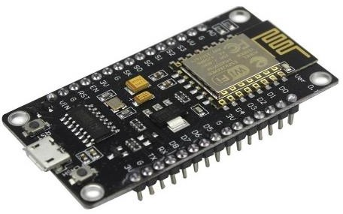USB connector: Micro USB
* Operating voltage: 3.3 v
* Flash Memory/SRAM: 4 MB / 64 KB
* Digital I/O Pins: 11
* Analog In Pins: 1
* ADC Range: 0 – 3.3 v
* WiFi Built-In: 802.11 b/g/n **NodeMCU**

## 2.2 RAIN SENSOR MODULE

**Description:**

The rain sensor module is an easy tool for rain detection. It can be used as a switch when raindrop falls through the raining board and also for measuring rainfall intensity. The module features, a rain board and the control board that is separate for more convenience, power indicator LED and an adjustable sensitivity though a potentiometer.

The digital output is used in detection of drops in the amount of rainfall.

Connected to 5V power supply, the LED will turn on when induction board has no rain drop, and DO output is high. When dropping a little amount water, DO output is low, the switch indicator will turn on. Brush off the water droplets, and when restored to the initial state, outputs high level.

##### Features:

It has good sensitivity to toxic gas in wide range, and has advantages such as long lifespan, low cost and simple drive circuit &etc.

##### Main Applications:

It is widely used in domestic gas alarm, industrial gas alarm and portable gas detector.

##### SPECIFICATIONS:

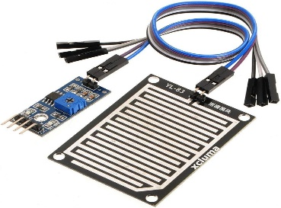

* Operating Voltage: 5V.
* Small board PCB size: 3.2cm x 1.4cm;.
* Anti-oxidation, anti-conductivity, with long use time;.
* Potentiometer adjust the sensitivity;
* Output format: Digital switching output (0 and 1)
* digital voltage output DO;

##### Application:

* water preservation device
* Irrigation Systems
* Automatic Cars

## Rain Drop Sensor Module

**2.3 LDR MODULE (LIGHT DEPENDENT RESISTOR):**

Resistance and Light Intensity: The resistance of an LDR decreases with increasing light intensity and increases with decreasing light intensity. In bright light, the resistance is low, allowing more current to pass through, while in darkness, the resistance is high, restricting current flow.

Material: LDRs are typically made of semiconductor materials like cadmium sulfide (CdS), which exhibit photoconductivity.

##### SPECIFICATIONS:

* Sensitivity is High.
* Simple and small devices.
* Easily used.
* Inexpensive.

##### APPLICATIONS:

* Automatic Lighting Systems: LDR sensors are used in systems that automatically turn lights on or off depending on the ambient light level.
* Light Meters: Used in photography to measure the amount of light for exposure settings.
* Street Lighting: Commonly used in streetlights to turn them on when it gets dark and off when it becomes light.

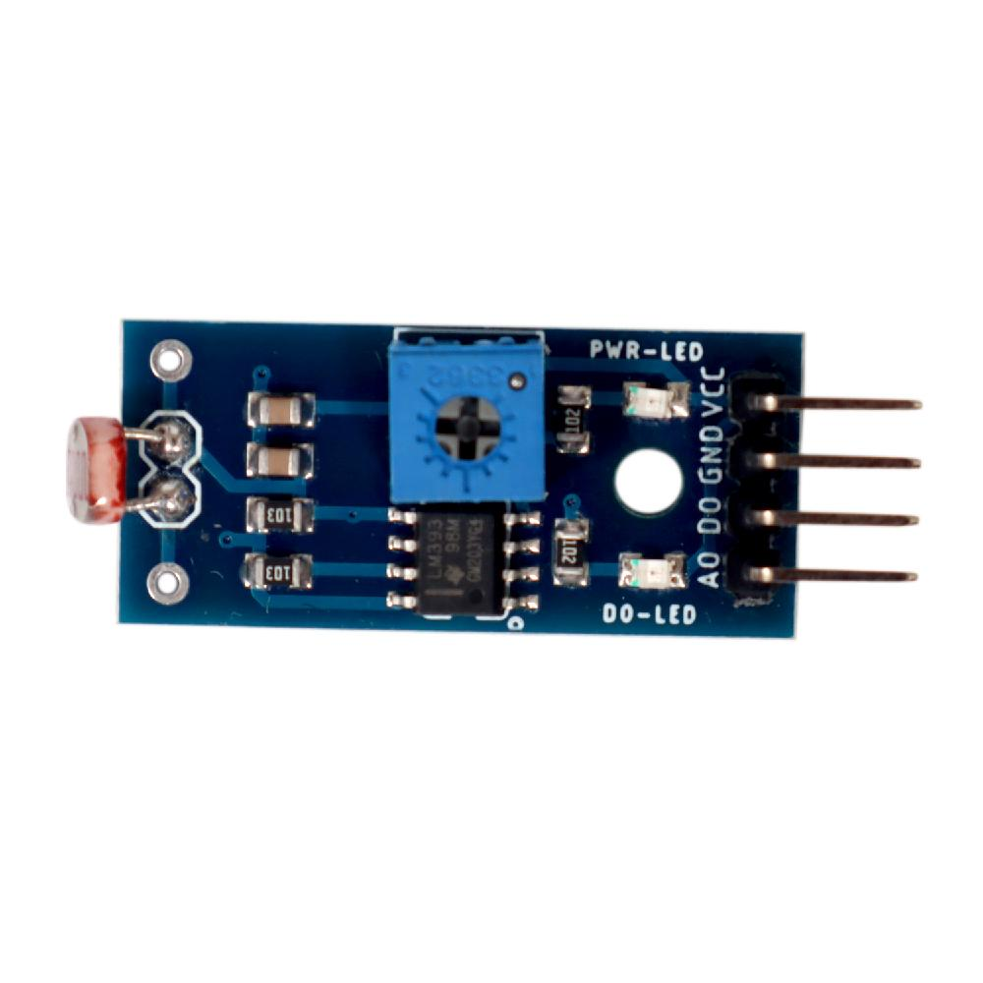

## LDR Module

**2.4 DHT11**

DHT11 digital temperature and humidity sensor is a calibrated digital signal output of the temperature and humidity combined sensor. It uses dedicated digital modules capture technology and the temperature and humidity sensor technology to ensure that products with high reliability and excellent long-term stability. Sensor includes a resistive element and a sense of wet NTC temperature measurement devices, and with a high- performance 8-bit microcontroller connected.

##### Applications:

HVAC, dehumidifiers, testing and inspection equipment, consumer goods, automotive, automation, data loggers, weather stations, home appliances, humidity regulator, medical and other relevant humidity measurement and control.

##### Product Highlights:

Low-cost, long-term stability, relative humidity and temperature measurement, excellent quality, fast response, anti-interference ability, long distance signal transmission, the digital signal output, precise calibration.

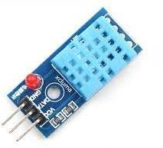

**DHT11**

##### SPECIFICATIONS:

* 3 to 5V power and I/O
* Good for 20-80% humidity readings with 5% accur

acy

acy nd)

* Good for 0-50°C temperature readings ±2°C accur
* No more than 1 Hz sampling rate (once every seco

**How to use DHT11 Sensor:**

The DHT11 Sensor is factory calibrated and outputs serial data and hence it is highly easy to set it up. The connection diagram for this sensor is shown below.

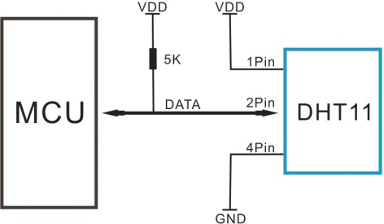 As you can see the data pin is connected to an I/O pin of the MCU and a 5K pull-up resistor is used. This data pin outputs the value of both temperature and humidity as serial data. If you are trying to interface DHT11 with Arduino then there are ready-made libraries for it which will give you a quick start.

If you are trying to interface it with some other MCU then the datasheet given below will come in handy. The output given out by the data pin will be in the order of 8bit humidity integer data + 8bit the Humidity decimal data +8 bit temperature integer data + 8bit fractional temperature data +8 bit parity bit. To request the DHT11 module to send these data the I/O pin has to be momentarily made low and then held high as shown in the timing diagram below

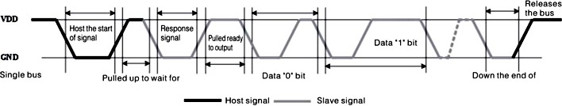

The duration of each host signal is explained in the DHT11 datasheet, with neat steps and illustrative timing diagrams.

### Applications:

* + Measure temperature and humidity
  + Local Weather station
  + Automatic climate control
  + Environment monitoring

**2D–model of the sensor:**

## MISCELLANEOUS COMPONENTS

##### USB MICRO B

Enable you to easily transfer all your files from or to cell phone. USB 2.0 data sync and power charger cable. Flat design, convenient use with portability and durability.

##### BREADBOARD

A thin plastic board used to hold electronic components (transistors, resistors, chips, etc.) that are wired together. Used to develop prototypes of electronic circuits, breadboards can be reused for future jobs. They can be used to create one-of-a-kind systems but rarely become commercial products. See [printed circuit board](https://www.pcmag.com/encyclopedia/term/printed-circuit-board).

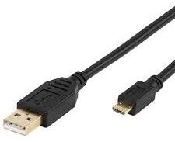

## USB MICRO B

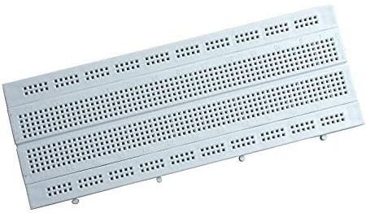

**Breadboard**

The breadboard contains spring clip contacts typically arranged in matrices with certain blocks of clips already wired together. The components and jump wires (assorted wire lengths with pins at both ends) are plugged into the clips to create the circuit patterns. The boards also typically include metal strips along the side that are used for common power rails and signal buses.

* + 1. **CONNECTING WIRES**

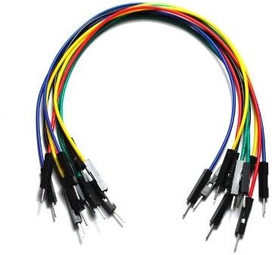

# 

**3.**

# Connecting wires

Jumper wires are simply wires that have connector pins at each end, allowing them to be used to connect two points to each other without soldering. Jumper wires are typically used with breadboards and other prototyping tools in order to make it easy to change a circuit as needed.

Though jumper wires come in a variety of colors, the colors don’t actually mean anything. This means that a red jumper wire is technically the same as a black one. But the colors can be used to your advantage in order to differentiate between types of connections, such as ground or power.

# SOFTWARE REQUIREMENT

* 1. **Arduino IDE**

The Arduino Integrated Development Environment - or Arduino Software (IDE) - contains a text editor for writing code, a message area, a text console, a toolbar with buttons for common functions and a series of menus. It connects to the Arduino and Genuino hardware to upload programs and communicate with them.

Programs written using Arduino Software (IDE) are called **sketches**. These sketches are written in the text editor and are saved with the file extension .ino. The editor has features for cutting/pasting and for searching/replacing text. The message area gives feedback while saving and exporting and also displays errors. The console displays text output by the Arduino Software (IDE), including complete error messages and other information. The bottom righthand corner of the window displays the configured board and serial port. The toolbar buttons allow you to verify and upload programs, create, open, and save sketches, and open the serial monitor.

Arduino is a company based in Italy that manufactures microcontroller boards, interactive objects, and kits that has created a full IDE to work on the hardware that they manufacture. It is the most preferred IDEs among all in the list. It is a complete package with many examples and pre-loaded libraries. Arduino is easy to use and implement so that a 10-year-old enthusiast can work easily with it. This IDE includes support for the C and C++ programming languages for programmable microcontrollers.

**Arduino IDE**

* 1. **Visual Studio Code**

**Visual Studio Code** (famously known as **VS Code**) is a free open-source text editor by Microsoft. VS Code is available for Windows, Linux, and macOS. Although the editor is relatively lightweight, it includes some powerful features that have made VS Code one of the most popular development environment tools in recent times.

VS Code supports a wide array of programming languages from Java, C++, and Python to CSS, Go, and Docker file. Moreover, VS Code allows you to add on and even creating new extensions including code linters, debuggers, and cloud and web development support.



**VS Code**

# Flowchart of Project:

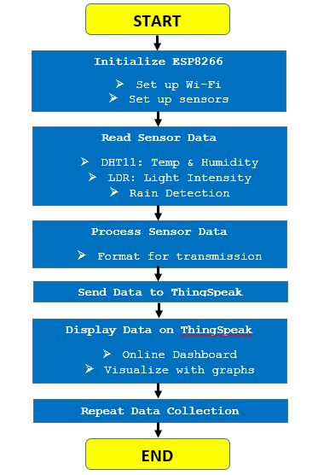

1. **BLOCK DIAGRAM OF PROJECT**

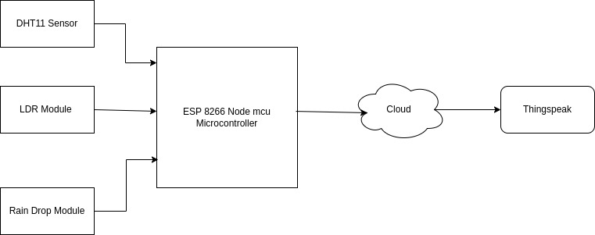

## Explanation of Block diagram

In this project we used three sensors DHT11(Temperature, Humidity) ,rain sensor,and LDR. According to block diagram NodeMCU ESP8266 collects data from those sensors and send it to the network after that same data is transferred to the MySQL data base using REST APIs and Flask. The collection of sensor data is real time so at the same time of data collection that data is stored in table which is created in MySQL data base. Table contains Serial no., Temperature, Humidity, rain detecion, ldr value.

## Project Design & Explanation

##### Project Design:

There are 3 parts in our Project –

* + 1. Hardware Part
    2. Server Part

## Hardware Part:

DHT11 ESP8266NodeMCU11

VCC ----> 3V3

Data pin ----> D4

GND ----> GND

LDR

Pin 1 ----> A0

Pin 2 ----> GND

Rain Detection Module

VCC ----> 3V

D0 ----> D1

GND ----> GND

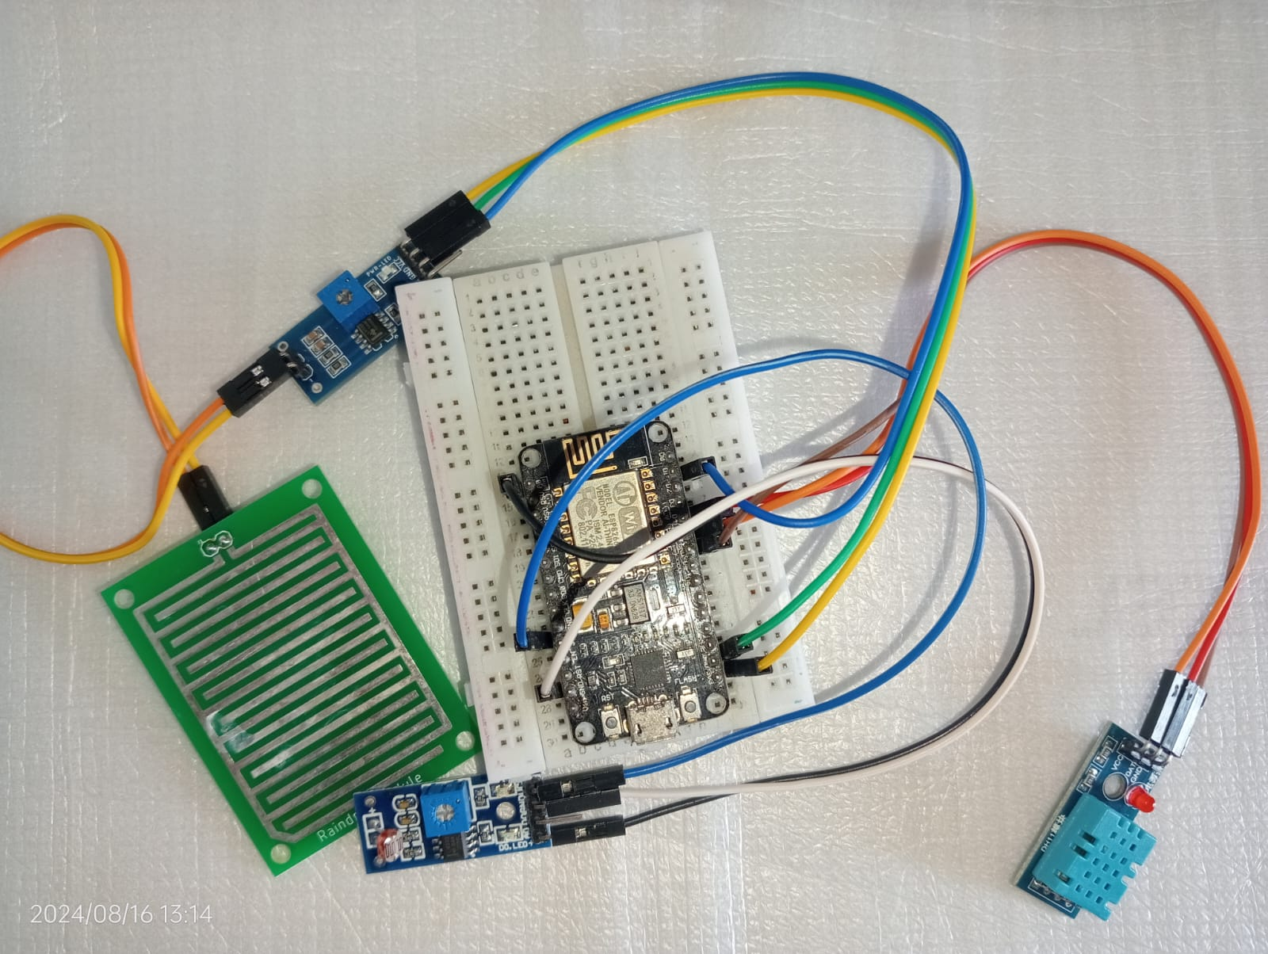

# 5.2.2 Server Part:

## REST Protocol

**Representational state transfer** (**REST**) is architecture for interactive applications that typically use multiple Web services. In order to be used in a REST-based application, a Web Service needs to meet certain constraints; such a Web Service is called RESTful. A RESTful Web service is required to provide an application access to its Web resources in a textual representation and support reading and modification of them with a stateless protocol and a predefined set of operations.

REST stands for Representational State Transfer. REST is web standards-based architecture and uses HTTP Protocol. It revolves around resource where every component is a resource and a resource is accessed by a common interface using HTTP standard methods. REST was first introduced by Roy Fielding in 2000.

In REST architecture, a REST Server simply provides access to resources and REST client accesses and modifies the resources. Here each resource is identified by URIs/ global IDs. REST uses various representation to represent a resource like text, JSON, XML. JSON is the most popular one.

##### HTTP methods:

Following four HTTP methods are commonly used in REST based architecture.

* GET − Provides a read only access to a resource.
* POST − Used to create a new resource.
* DELETE − Used to remove a resource.
* 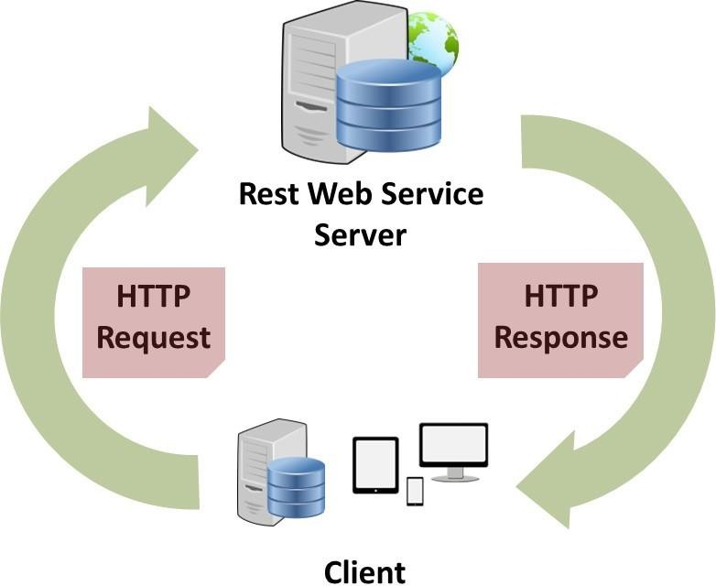PUT − Used to update existing resource or create a new resource.

**REST Protocol**

## MySQL Database

MySQL is a freely available open-source Relational Database Management System (RDBMS) that uses Structured Query Language (SQL). SQL is the most popular language for adding, accessing and managing content in a database. It is most noted for its quick processing, proven reliability, ease and flexibility of use.



MySQL is a fast, easy-to-use RDBMS being used for many small and big businesses. MySQL is becoming so popular because of many good reasons:

MySQL is released under an open-source license. So you have nothing to pay to use it. MySQL is a very powerful program in its own right. It handles a large subset of the functionality of the most expensive and powerful database packages. MySQL uses a standard form of the well-known SQL data language. MySQL works on many operating systems and with many languages including Python, PHP, PERL, C, C++, JAVA, etc. MySQL works very quickly and works well even with large data sets. MySQL is very friendly to Python, the most appreciated language for web development. MySQL supports large databases, up to 50 million rows or more in a table. The default file size limit for a table is 4GB, but you can increase this (if your operating system can handle it) to a theoretical limit of 8 million terabytes (TB). MySQL is customizable. The open-source GPL license allows programmers to modify the MySQL software to fit their own specific environments. In Smart Parking this database keeps the status of user’s registration their logins for parking booking. It also keeps the status of admin login through which admin can see the status of parking slots in a parking area and can keep a track on user.

**Thingspeak: A IoT web Service**

Thingspeak is a web based open API IoT source information platform [04, 05, 06] that comprehensive in storing the sensor data of varied ‘IoT applications’ and conspire the sensed data output in graphical form at the web level. Thingspeak communicate with the help of internet connection which acts as a ‘data packet ’carrier between the connected ‘things’ and the Thingspeak cloud retrieve, save/store, analyse, observe and work on the sensed data from the connected sensor to the host microcontroller such as ‘Arduino, TI CC3200 module, Raspberry-pi etc.

The Thingspeak helps to form a captivate sensor based logging applications, location/place tracing application and ‘social network’ of objects/things with updated status and alternatively we can have a control over ‘Home automation’ products that were connected to the public domain network (via Internet) from the location of existence and The most primary feature of Thingspeak functionality is the term ‘Channel’ that have field for data, field for location, field for status for varied sensed data. Once channels are created in the ‘Thingspeak’ the data can be implemented_ and alternately one can process and visualize the information using the MATLAB and respond to the data with tweets and other forms of alerts. Thingspeak also provide a feature to create a public based channel to analyse and estimate it through public.

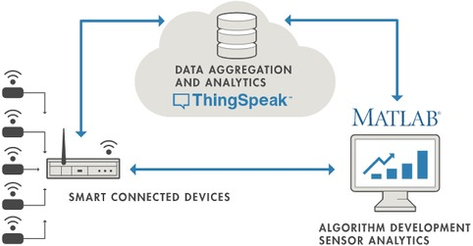

To Engage the ‘Things/objects’ in sensing the respective data and transmitting across the Internet and one involves to go further just connecting data from a PC, objects to collect (sensors)And to do so the data require to network uploaded that are in the form of servers (that runs applications) and such types are considered as Cloud .The ‘Cloud’ utilizes the operations of Graphical visualization and available in the form of Virtual server for the users and the objects are communicated with the cloud via possible ‘wireless internet connections’ available to the users and majority objects uses the sensors/actuator to tell regarding our environmental analogue data. The IoT Helps to bring all things together and permits us to communicate with our very own things and even more curiously allows objects/things to interact with other ‘things’.

**Setting Thingspeak & Getting API Key:**

* + - 1. Go to [**https://thingspeak.com/**](https://thingspeak.com/) and create an account if you do not have one.

Login to your account.

* + - 1. Create a new channel by clicking on the button. Enter the basic details of the channel. Then Scroll down and save the channel. You can follow the video guide below.
      2. Then go to API keys copy and paste this key to a separate notepad file. You will need it later while programming.

# RESULT

#### Database:

#### 

Pic: Table update in Database

* 1. **Thingspeak Channel Graphical Representation**

**1. TEMPERATURE :**

# 2. HUMIDITY :

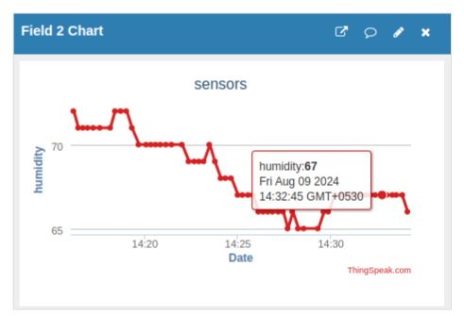

## 3. LDR VALUE :

## 

## 4. RAIN DETECTION:

## 

**7. The advantages of IoT weather stations mainly include:**

* + - Efficiency: IoT weather stations can monitor weather data in real time and are able to transmit and process data quickly, improving the efficiency and accuracy of weather monitoring.
    - Accuracy: Equipped with high-precision sensors and intelligent processing systems, IoT weather stations can provide more accurate weather data, which helps to improve the accuracy and refinement of weather forecasts.
    - Automation: IOT weather station can realise automated data collection, transmission and processing, which reduces manual intervention and errors and improves the objectivity and reliability of data.
    - Expandability: IOT weather station can realise remote control and data transmission through IOT technology, which is convenient for system upgrading and expansion, and can adapt to the ever-changing meteorological monitoring needs.
    - Low cost: the construction and maintenance cost of IOT weather station is relatively low, which can achieve more efficient weather monitoring and management, and at the same time can reduce the input of manpower and material resources.

# 8. Approximate Costing

|  |  |
| --- | --- |
| **Components** | **Price** |
| NodeMCU ESP8266 | 250 Rs. |
| DHT 11 | 110 Rs. |
| RAIN SENSOR  LDR SENSOR | 112 Rs.  110 Rs. |
| BREADBOARD | 55 Rs. |
| CONNECTING WIRES | 30 Rs. |
| USB MICRO B | 30 Rs. |
| **Total** | **577 Rs.** |

**9. FUTURE SCOPE**

Our project objective is to provide real time updates of weather conditions . It can be used for many industrial application such as Agricultural use , Warehouse management and Aviations (Design , development and use of aircraft it includes all activities related to client ) Future work will be based on the EEPROM. Though the power supply is off then all data will be saved in [EEPROM chip and when power supply is on it will displayed on LCD]. The project can also work upon GSM technology, where the information will be sent to user via SMS.

Multiple sensors and actuators can be connected to the circuit so that compony and its workers protected from dangerous hazards by continuous environment monitoring.

# 10 . Conclusion

The proposed system will be able to record data and store it directly in saver’s own MySQL Database as storage unit and send the same format to Web page and Mobile Application. Stored data is transferred wirelessly. No data loss is done while wireless failure hence proving its reliability also makes easy to collect data in extreme conditions without any issues.

They avoid the time and expense of sending someone to take measurements in a remote location, and they enable much higher data density than is achievable through manual recording, providing higher quality data.

# 11 . References

1. Global Journal for Innovative Research in Science and Technology (IJIRST)-

Volume 1-May 2015' the Real Time Temperature Sensing utilizing Raspberry Pi

1. M. Rahaman Laskar, R. Bhattacharjee, M. Sau Giri and P. Bhattacharya, "Climate Forecasting utilizing Arduino Based Cube-Sat", Twelfth International Multiconference on Information Processing (IMCIP) – 2016
2. Vinayak Appasaheb Pujari, Mrs. M. M. Raste, Ms. A. A. Pujari, "Savvy Automatic Weather Station-a Review", International Journal of Electrical and Gadgets Engineers (IJEEE)- Vol. No. 8 Issue 01, January-June 2016
3. Prof. Satyashil Nagrale, Ms. Poonam Khetmalis, Ms. Sanika Doke, Ms. Varsha Dherange, "Constant Data Transmission for Weather Monitoring System", Global Research Journal of Engineering and Technology (IRJET)- Volume: 03 Issue: 02,

Feb 2016

1. Sheik Ferdoush, Xinorong Li, "Remote Sensor Network System Design utilizing Raspberry Pi and Arduino for Environmental Monitoring Applications”. Procedia Computer Science 34(2014) 103-110
2. Prof. C. H. Chavan, Mr. V. Karande "Wireless Monitoring of Soil Moisture, Temperature and Humidity utilizing Zigbee in Agriculture", International Journal of Building Trends and Technology (IJETT)- Volume 11 Number 10 – May 2014.
3. Juwariyah, Tatik & Prayitno, S & Krisnawati, L & Sulasminingsih, S. (2021). Design of IoT-Based Home Fire Detection System Equipped with a Data Logger. IOP Conference Series: Materials Science and Engineering. 1125. 012079. 10.1088/1757-899X/1125/1/012079.
4. ThingSpeak – an API and Web Service for the Internet of Things, a published paper
5. ThingSpeak: Open Source Platform for Connected Products and Services(PR Newswire)